**WATERNETIC**

**Efficient and Convenient Transactions**

Name of Author(s): Arnado, Jefferson, B.1 Tabilog, James Jecemeco, A.2

1 Author #1: BSIT-4, Blk 2 Lot 11 Lorenzo Homes, Upper Piedad, Barangay Bato, Toril, Davao City, jeparnado@gmail.com

2 Author #2: BSIT-4, Purok 10 Nazareno St., Lubogan, Toril, Davao City, jecemecojamestabilog@gmail.com

**ABSTRACT**

Water management is crucial for communities, yet many still rely on manual methods, leading to inefficiencies and data inconsistencies. The Waternetic project introduces a digital system to modernize water management by leveraging technology. Key beneficiaries include homeowners, water meter readers, and subdivision owners. Homeowners gain easy access to water monitoring, aiding decision-making and reducing costs. Digital tools enhance efficiency for meter readers, saving time and ensuring accurate data. Subdivisions benefit from streamlined processes and financial savings. Waternetic aligns with Sustainable Development Goals (SDGs) 6 and 13, focusing on clean water and climate action. It aims to promote responsible water use and reduce paper waste, connecting traditional management with technology for a sustainable future.

*Keywords:* **water management, digital system, efficiency, sustainability**

**1. INTRODUCTION**

Water management is an essential communal undertaking, but numerous areas still depend on manual techniques, resulting in operational inefficiencies, inconsistencies in data, and environmental apprehensions (Miller et al., 2023). The capstone project presents Waternetic, a digital system that aims to revolutionize water management techniques by utilizing technology to tackle these difficulties.

The initiative's primary beneficiaries are homeowners, water meter readers, and subdivision owners. Homeowners can benefit from easy water use monitoring and well-informed decision-making, which has the potential to decrease water expenses. The adoption of digital technology by water meter readers will result in increased efficiency, as it saves time and guarantees accurate data collection. Subdivision owners can anticipate efficient processes and significant financial benefits from water distribution.

The initiative stems from the need to address inefficiencies in current water management systems. Waternetic utilizes system software, algorithms, and efficient processes that are in line with enterprise resource planning (ERP) principles, providing a cutting-edge answer to this essential aspect of contemporary existence.

This capstone project is in line with Sustainable Development Goals (SDG) 6 and 13, which specifically target clean water and climate action. The goal is to raise awareness about responsible water usage and reduce paper waste. This initiative represents a significant advancement in the management of sustainable water resources and showcases how capstone projects may effectively tackle real-world issues (Villanueva, 2012). Waternetic aspires to connect traditional water management with new technology, helping us move towards a more sustainable future.

**2. OBJECTIVES**

The project aims to address numerous issues with homeowner data management and improve the efficiency of water bill payment. More precisely, its objective is to enhance the efficiency of obtaining information about homeowners, minimize the frequent misplacement of water bill payment receipts, and simplify the procedure of paying water bills in order to save time. These goals will improve the overall accessibility of data and simplify the payment procedure for homeowners.

**3. MATERIALS AND METHODS**

Waternetic is a web and mobile app developed for exploratory and experimental research purposes. This investigation involves conducting interviews and gathering data from Gilberto Poria, a water meter reader at Don Lorenzo Homes Subdivision, Upper Piedad, Barangay Bato, Toril, Davao City, as well as homeowners within the subdivision. The team has completed the alpha testing phase and is now gearing up for beta testing to collect feedback from a wider audience. Another way of validating the flow of the capstone project is by joining startup competitions in which a pool of experts shared their feedback for the improvement of the project. In Figure 1, the system architecture is presented to show the transmission of data within the system through the users, hardware, software, and database.

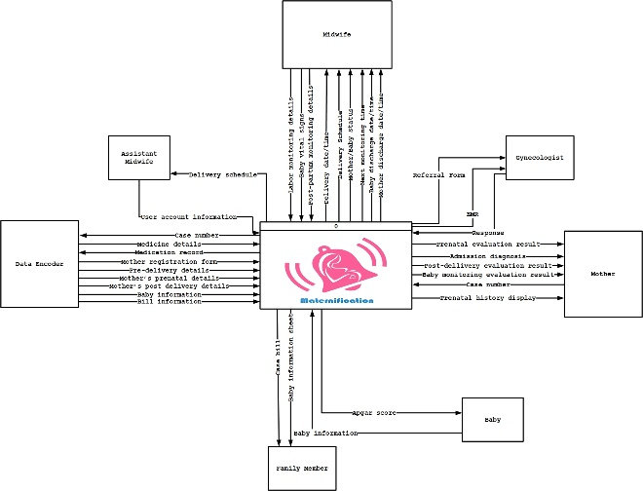

Figure 1.Waternetic system architecture

**4. RESULTS AND DISCUSSIONS**

After three years of development, the identified solutions to the major problems are now presented in wireframes to illustrate visual models.

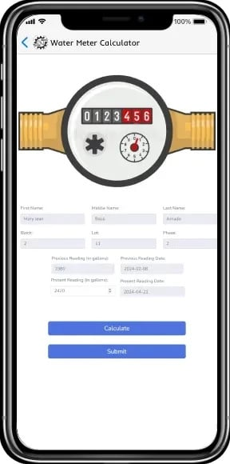

Figure 2. Digital water meter reader

Figure 2 is the wireframe that shows the solution to the slow retrieval of the homeowner’s data. Instead of waiting for the printed water bill, the homeowner’s account has an interface for inputting the water consumption to give up-to date information. The water meter reader also has the same interface that is used in generating the actual water bill. The Waternetic will integrate digital water meter as an identified innovation, which will be launched after beta testing.

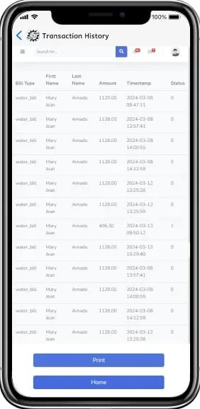

Figure 3. Transaction history

Misplacing the receipt or the water bill is a common issue for homeowners. Figure 3 shows the transaction history, which lists the details of the transactions. In this manner, the homeowner's accounts can store the proof of every transaction.

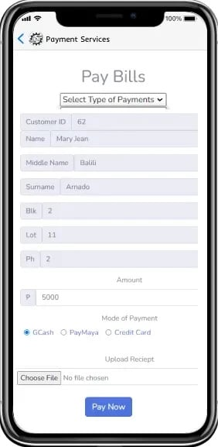

Figure 4. Water bill payment

In the study conducted by Jain and Gupta (2023) titled "Balancing the Risk and Rewards of a Cashless and Digital Society," it is found that a society that operates without cash and relies on digital transactions has the capacity to yield substantial advantages. These advantages include enhanced efficiency and convenience, decreased transaction expenses,and diminished possibilities for criminal activities. Nevertheless, it also entails certain hazards, such as the possibility of economic marginalization, data breaches and cyberattacks, and the erosion of privacy. Figure 4 illustrates the promotion of cashless payment transactions for homeowners in Waternetic. This provides a more versatile payment platform for homeowners.

**5. CONCLUSIONS**

Over the past 20 years, more than 80 major cities around the world have experienced acute water shortages due to droughts and irresponsible water consumption. Future predictions indicate that urban water crises will intensify, disproportionately affecting those with lower social, economic, and political status (Savelli et al., 2023). The development of Waternetic as a web and mobile application is significant in tackling the problem of water consumption control. It accomplishes this by remotely monitoring usage and related issues through a transparent interface on internet-connected smart devices.

**6. ACKNOWLEDGEMENT**

It is with great pride that we present Maternification. We want to express our absolute gratitude to our instructor Mr. Ser Jamier Llego for his encouragement and steadfast support in our undertaking of this research. God bless him! Lastly, this research would not have been completed without the support and motivation from our beloved family, friends, colleagues, instructors, and classmates who have been with us through thick and thin. Above all, thank you to the God Almighty, the author of knowledge and wisdom, for his constant blessings.

**7. REFERENCES**

Jain, H., & Gupta, P. (2023) Balancing the Risk and Rewards of a Cashless and Digital Society.

Miller, M., Kisiel, A., Cembrowska-Lech, D., Durlik, I., & Miller, T. (2023). IoT in water quality monitoring—Are we really here?. Sensors, 23(2), 960.

Savelli, E., Mazzoleni, M., Di Baldassarre, G., Cloke, H., & Rusca, M. (2023). Urban water crises driven by elites’ unsustainable consumption. Nature Sustainability, 6(8), 929-940.